Flower Pop-up Card Instructions

Packet Contains:
1 sheet of card stock
7 5X5in squares of paper
Petal pattern piece
Will need:
Liquid glue or double sided tape
Scissors
Colored pencils, crayons, or paint

Instructions:
Watch video first: https://www.youtube.com/watch?v=Z3FLg50qpu8
- Fold 5x5 squares diagonally into quarters (there should be 8 triangles when finished)
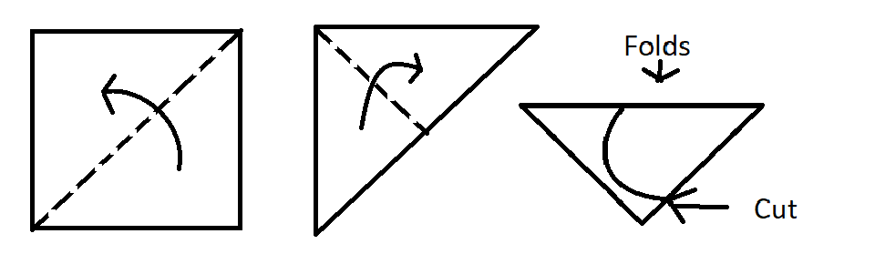
- Cut folded paper into a petal shape along the edge with no folds, feel free to use the petal pattern provided
- Draw flower center, add additional decoration if desired
- Cut out one triangle of the flower (should leave 7 petals) and glue the petals next to the gap together.
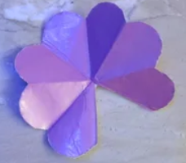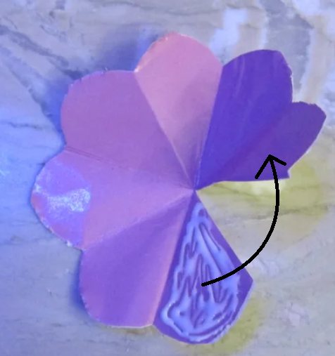
- Refold flowers in half so that all creases are facing inward
- Using a single dot on the flower petal, glue flowers together in the following pattern
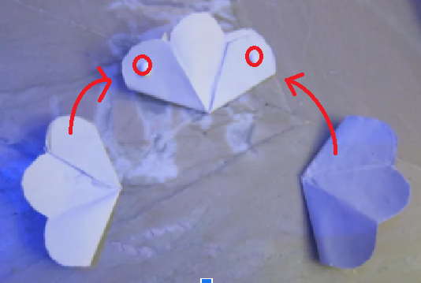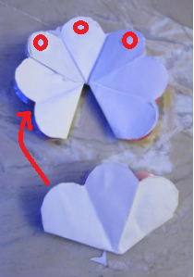
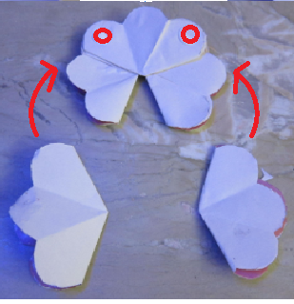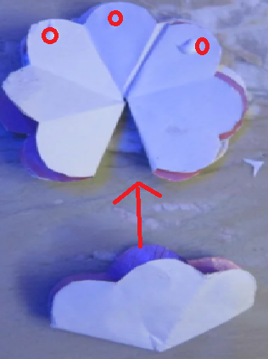
- Line up the flower cluster along the crease of the card and glue the center petal of the first flower to the cardstock. Wait for it to dry.
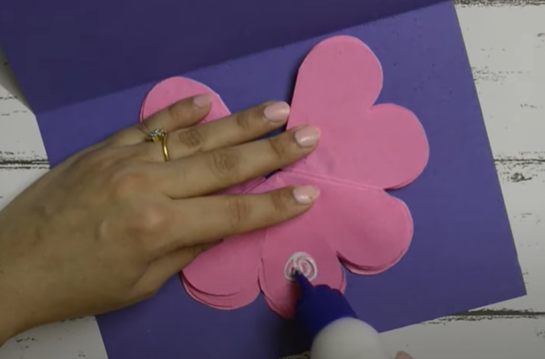
- Add glue to the center petal on the opposite side, and close the card. Wait for it to dry.
- Open the card, check all the glue worked
- Write a message on the front of the card and name under the bouquet.

