Paper Flower - Classic

For one flower, you will need five petals.

- Create perfect squares of paper, somewhere between 3 square inches and 5 square inches.
- Fold each square into a triangle:
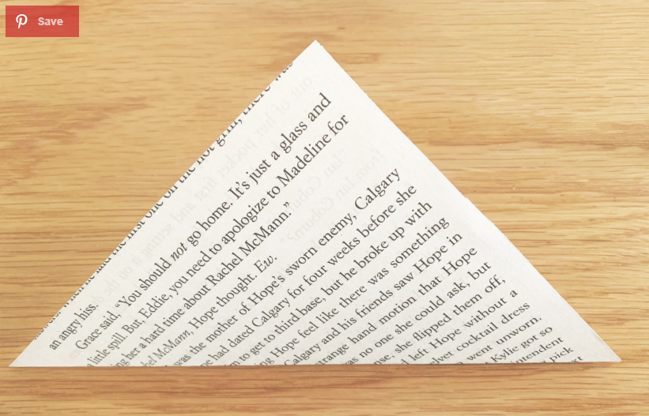

- Fold the right point of the triangle to the top point of the triangle, and then the left point to the top of the triangle, creating a square.
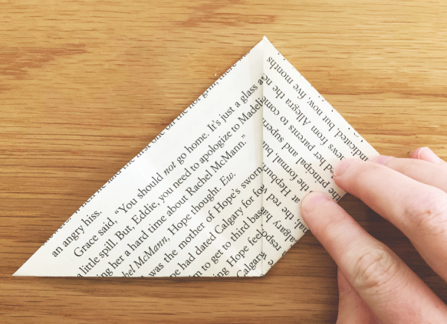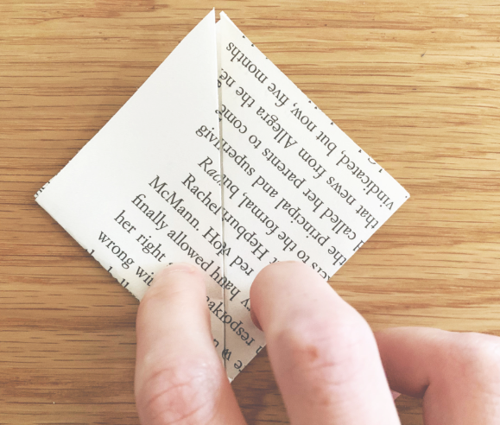

- Pop out the right triangle and press the triangle flat with the creases lining up together.
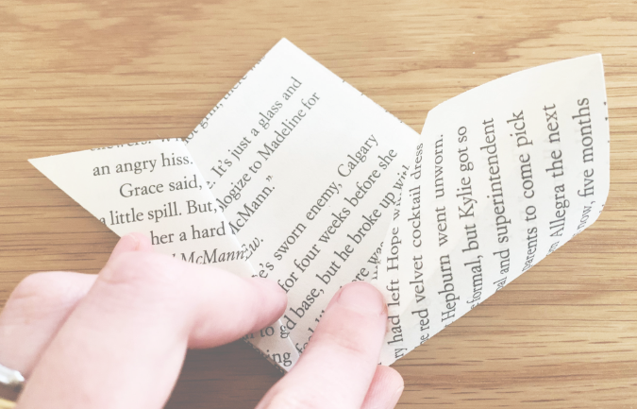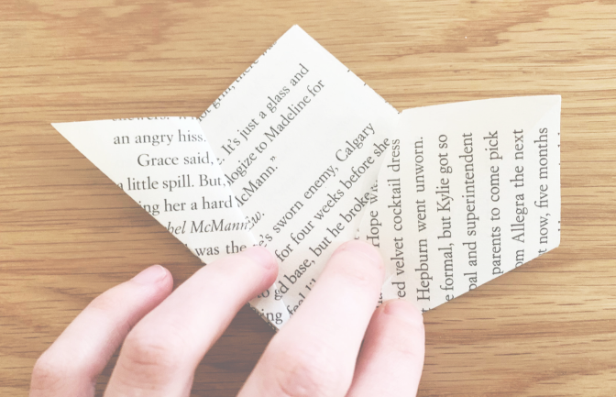

- Repeat with the other side until you have something that looks like this:
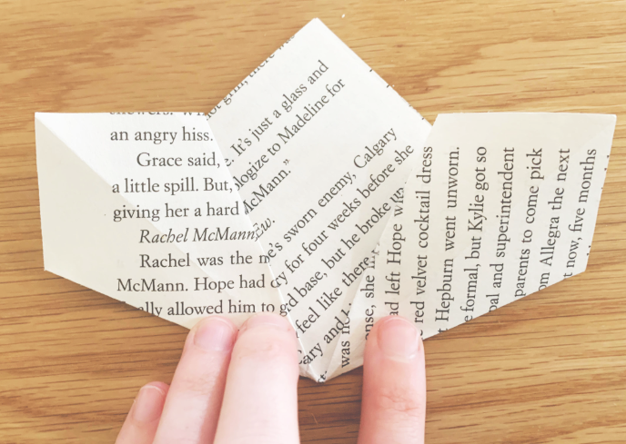

- Fold the top flaps of the right and left diamonds down, so that they are even with the line from the center point.
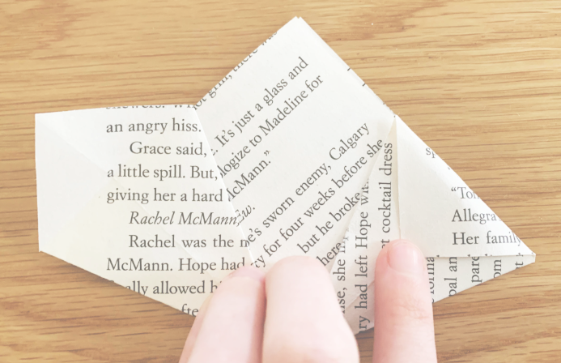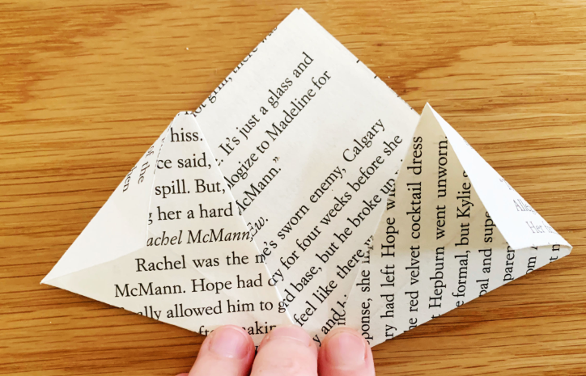

- Now take the sides and fold it over towards the center. You will already have a crease here from your earlier fold.
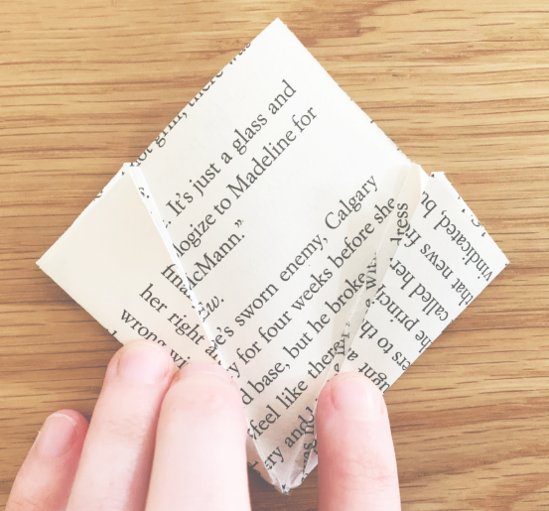

- Next, “curl” up both sides to meet. Don’t crease this part. You want it rounded like a flower petal.Then glue the edges together.
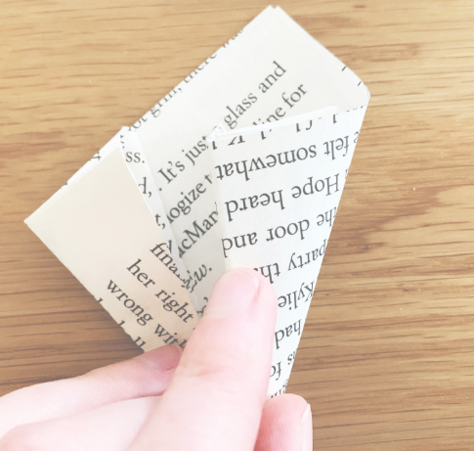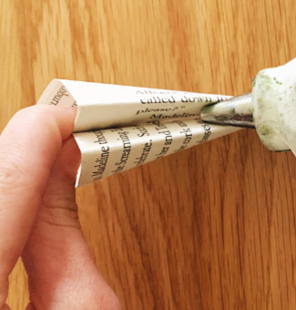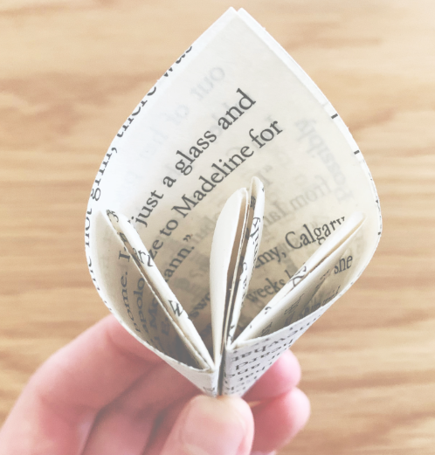

- Repeat this on the remaining 4 petals, or as many petals for as many flowers as you would like to make.

- Glue the petals together to form a 5 petal flower. This is easier if you glue them around the stick.
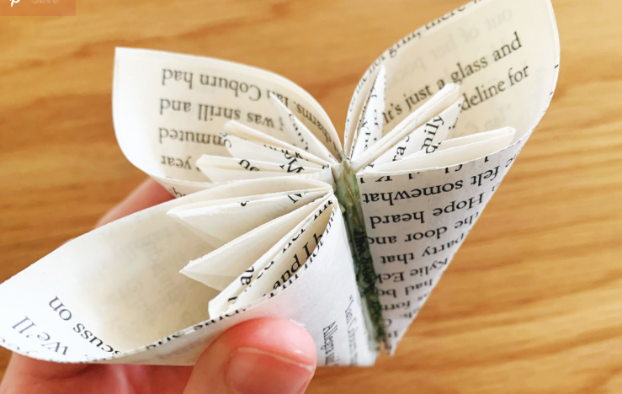

- If you did not glue around the stick, simply apply glue to the bottom of the flower, and glue the stick to form a stem.
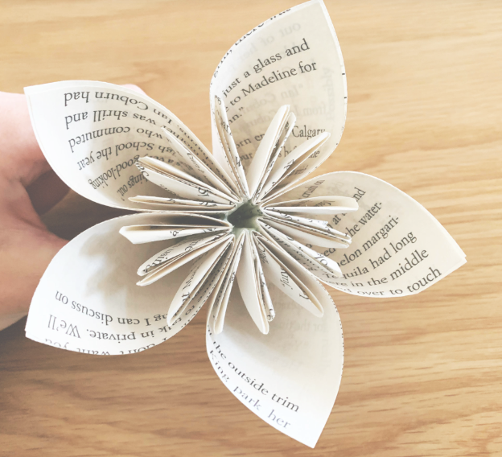

Paper Flower - Rose
For one flower, you will need 4 squares of paper.

- Start by creating 4 perfect squares of paper that are a minimum of 4 square inches.
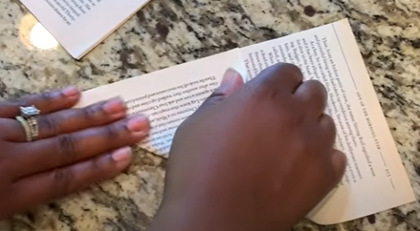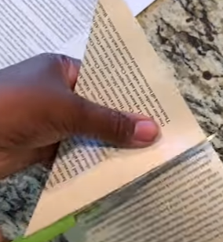

- Fold the square in half along a diagonal to create a triangle.
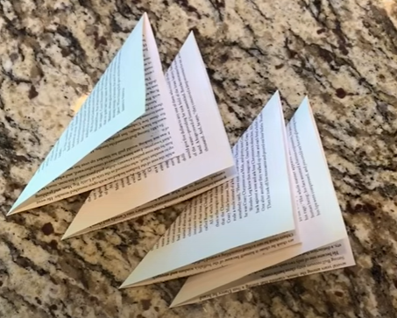

- Take a triangle, and fold it in half to form a smaller triangle. Then fold it in half again to form an even smaller triangle. (3 folds total)

- Take your tripled folded triangle and cut an icecream cone shape, being sure not to cut off any of the edges with folds.
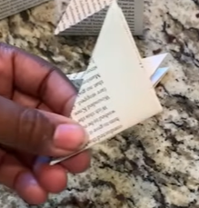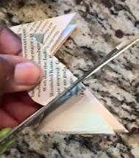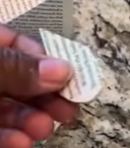

- Cut the bottom corner off the ice cream cone.

- Repeat the process with 3 other pieces of paper.

- Unfold your ice cream cones into a 8 petaled flowers.
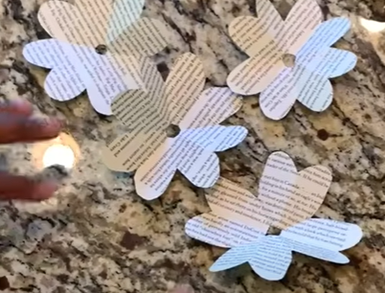

- Cut 1 petal out of the first flower:
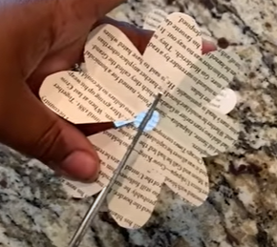

- Cut 2 petals out of the second flower

- Cut 3 petals out of the third flower

- Cut 4 petals out of the fourth flower (cut it in half)
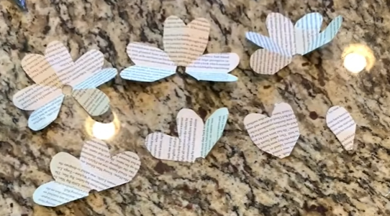

- Now glue the edge petals together on all 7, 6, 5, 4, 3 petal sets.
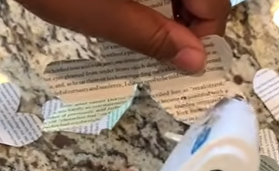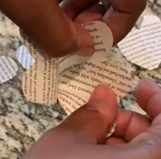

- Curl the two petal section and the one petal sections around a stick or by using your fingers.
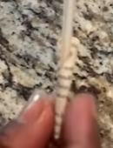

- Glue the 5 petal flower into the 6 petal flower by applying hot glue around the bottom edge of the flower, near the center hole.

- Repeat the process with successively smaller flowers.
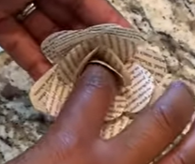

- Once all the petal sets are glued together, use a stick to curl the outside edges of the flower petals.
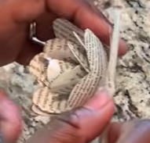

- Glue a stick onto the bottom of the flower to form a stem.
