Patriotic Wreath Instructions:
Materials:
- About 20 4X4 inch blue cardstock squares
- About 21 4X4 inch white cardstock squares
- About 12 4X4 inch red card stock squares
- Silver star
- 1 large cardboard circle
- 1 small cardboard circle with stand
- Hot glue gun
- All the hot glue sticks

Instructions:
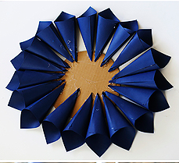
- Take the blue squares and roll them into ice cream cones. Apply a line of hot glue about a centimeter in from the edge of the paper and glue it into cone shape. Repeat about 20 times.

- Glue the blue cones around the outer edge of the large cardboard circle at about 2 centimeters in. Tip, you want about the diameter of a quarter in distance from one cone to the next.

- Repeat step 1, but with the white squares. You will want about 18 white cones.
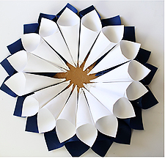
- Glue the white cones about an inch closer into the cardboard circle in the spaces between the blue cones.

- Repeat step 1, but with the red squares. You will want about 12.

- Glue the red cones in between the white cones about an inch from the center of the circle.

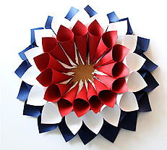

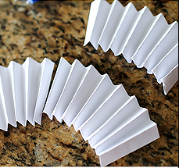
- Glue the small circle platform into the center of the large cardboard circle

- Take 3 white squares and accordion fold them. Then cut them in half.

- Create circle with the folded accordion fans by gluing them to the small central circle.

- Glue the star to the center of the white circle.
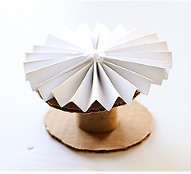
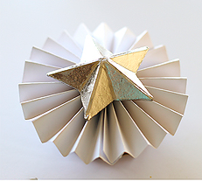
- Glue the wire loop to the back of the wreath so you can hang it up later.

