Painted vacation Sign

Materials:
Wooden sign
Spong brushes
Paint
Pallet
Water cup
Stencils
Masking tape
Paper towels

Instructions:
- Identify which stencil or stencils you would like to use for your vacation sign
- Select paint that for the colors you would like to use from the front and add about a quarter sized amount onto the pallet/plate.
  - Color selection:
    - Choose 3 sets of complimentary colors
    - Choose 2 sets of complimentary colors
    - Choose 5 colors of the same saturation value
- Use the tape to place your stencil where you want it to go.
- Tape off the sections of the stencil you do not want to use.
- Use the sponges to add color to your sign. Use a new spong for each color set (use the blue spong for your blue, use the yellow sponge for your yellow colors)
- To create a gradient
  - Identify the two colors you want to transition between
  - Begin by sponging your chosen color along the top, then add some of the new color to the brush without cleaning it, repeat steps until your brush is the color you are transitioning to.
- Wait for your first set of stenciling to dry before you move onto the next

Note: the Wood has been sealed for you using mod podge

Possible Color Schemes:

Color Wheel:
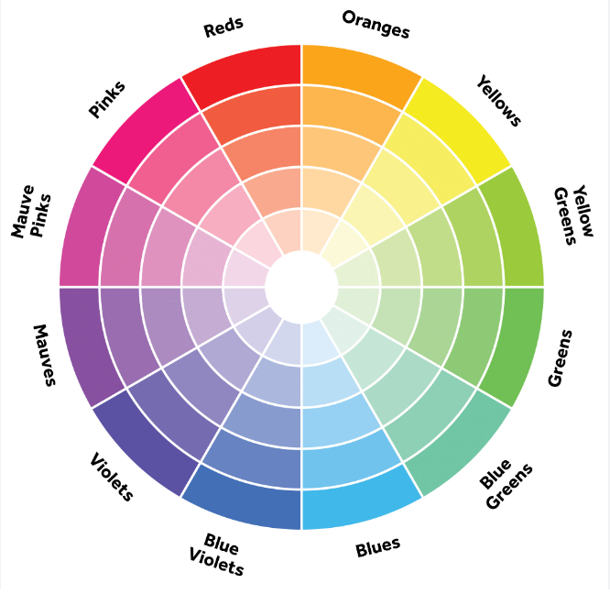

Color Mixing:
Red + Blue = purple
Red + Yellow = Orange
Blue + Yellow = Green
White + Black = Grey
White + Red = pink
Green + Blue = turquoise

