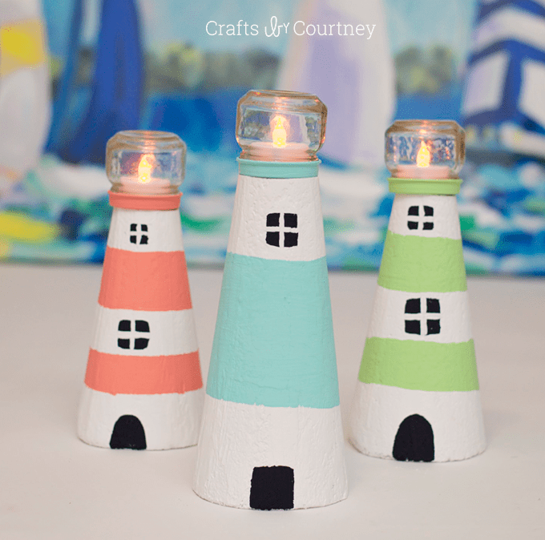

Miniature Lighthouse Instructions
Materials Needed:
Foam Cone
Baby Food Jar
Paint Brush
Rubber bands
Acrylic paint - white, black, color of your choice
Hot glue gun and glue
Shells
Fake votive candle

Instructions:
Cutting the foam top of the cone and adding foam clay has been done for you.

- Paint the top clay portion of your cone using your chosen color or colors.

- Use the rubber bands and measuring tools at your table to mark out where you want your stripes of color to go. I suggest either one or two stripes of color. (image on next page)
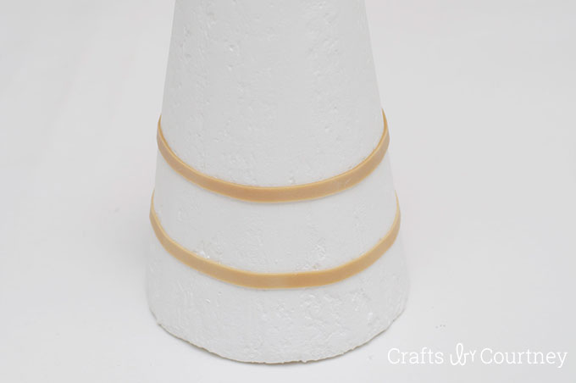

- Carefully paint in between the rubber bands with your chosen color.

- Identify the front of the lighthouse and paint the door that is about an inch tall with the black paint. It can either be a curved or rectangle.

- Identify where you would like your windows to go on the front and back of the lighthouse.

- Paint the tiny windows in black paint. The window configuration is 4 squares in a grid pattern.
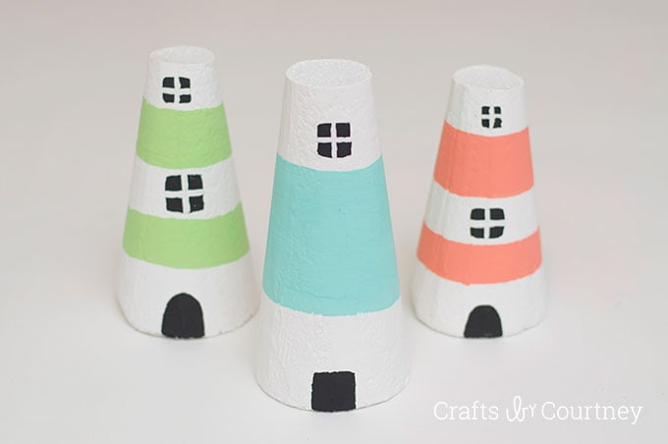

- Use the hot glue gun to add shells in a configuration that you like.

- Put the fake votive candle at the top

- Shimmy the baby food jar down the length of the tower until it sits snuggly.

- Enjoy your tiny lighthouse.

