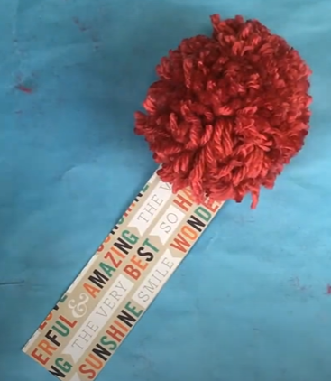
Pom-Pom Bookmark

Materials:
- Yearn
- Cardboard pom-pom template
- Strips of paper

Not included:
- Scissors
- glue

Video Instructions: https://youtu.be/ExOunPco-r0

Instructions:
- Choose between the strips of cardstock paper, and glue two together. Wait for the glue to dry.
- Cut off a section of yarn from the skein that is about 8 inches long.
- Cut out the outer circles on the two cardboard pom-pom templates
- Cut a wedge in the circle following the black lines into the inner circle on the template. Repeat with the other cardboard template.
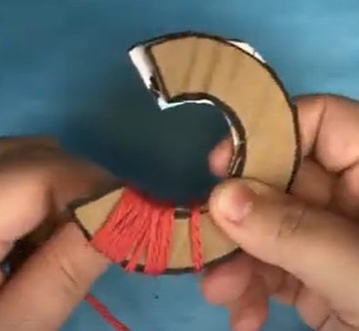
- Cut out the inner circle of the template. Repeat with the other cardboard template.
- Stack the two cardboard templates on top of each other and line the edges up as well as is possible.
- Take the end of the yarn skein, and begin wrapping it around the two templates. Wrap from one edge to another, winding it tight. Make sure to leave a little space at the end of each template.
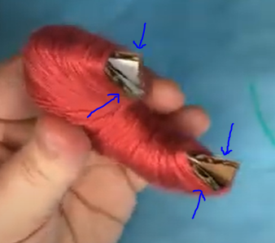
- Once the template is completely wrapped with the whole skein of yarn, bend the little pieces of cardboard that you left visible outwards to use a guide for the scissors.
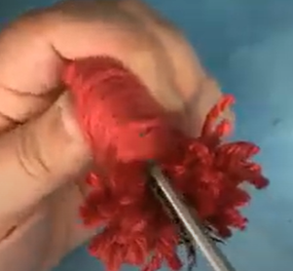
- Following the seam between to the 2 pieces of cardboard, start trimming the ridge of the yarn about an inch or two on both sides of the yarn crescent. Tip, make sure to hold the yarn in place with your thumb on the bottom of the crescent so none of the small pieces fall off the template.
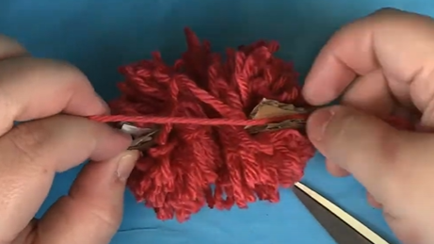
- Take the spare piece of yarn that you cut off at the beginning, and tuck it between the two pieces of cardboard, drawing the string tight over the bottom of the crescent, which will hold the rest of the yarn in place while you continue cutting the rest of the yarn along the ridge.
- Once all the yarn is cut, take the spare piece and pull it taut to the center. The tie it twice, pulling as hard as you can.
- Take out the remaining pieces of cardboard and fluff your pom-pom.
- Use your scissors to trim the pom-pom so it is more spherical.
- Using the trailing ends from the pom-pom cord, tie it to the bookmark using the punched hole. Trim the remaining yarn.

