**Fall Strip Art**

Materials:

* Glue stick
* Strips of paper
* Template

Not included:

* Scissors

**Video Instructions:** <https://youtu.be/BqGYimKfpAU>

**Instructions:**

1. Pick out which template you would like to use (either the cat or the pumpkin)
2. Cut out the inside of your chosen template, by puncturing a hole in the center with a pen or pencil and cutting out the rest of the shape.

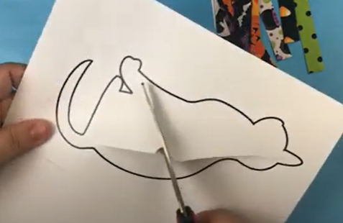

1. Fold the paper in half with the printed stencils facing the inside.
2. Line up your strips of paper along the inside back of the folded paper, and organize them in a way that makes you happy.

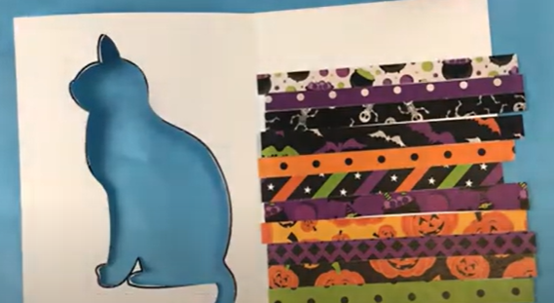

1. Once you have covered the area that will be visible through the cut out shape, glue the strips down and cut off the excess.
2. Glue around the edges of the paper and fold the card together. Put something heavy on top of it while it dries.

**Fall Strip Art**

Materials:

* Glue stick
* Strips of paper
* Template

Not included:

* Scissors

**Video Instructions:** <https://youtu.be/BqGYimKfpAU>

**Instructions:**

1. Pick out which template you would like to use (either the cat or the pumpkin)
2. Cut out the inside of your chosen template, by puncturing a hole in the center with a pen or pencil and cutting out the rest of the shape.



1. Fold the paper in half with the printed stencils facing the inside.
2. Line up your strips of paper along the inside back of the folded paper, and organize them in a way that makes you happy.



1. Once you have covered the area that will be visible through the cut out shape, glue the strips down and cut off the excess.
2. Glue around the edges of the paper and fold the card together. Put something heavy on top of it while it dries.