Canvas stitch art instructions

Materials:
- Canvas
- Yarn
- Needle
- Design template
Not provided:
- Pencil
- Tape
- scissors
Video: https://youtu.be/Lc9gzqEBKWM

Instructions:
- Cut out the templet.
- Flip the canvas over, insert the template, and trace the template on the back of the canvas with pencil or pen. Remove the template when finished.
- Use the needle to poke holes in each corner of the outline from the back of the canvas.
- Make more holes along the template lines about 1/16th of an inch apart. You will be sewing the yarn vertically, so poke holes that line up on the top and bottom of the shape.
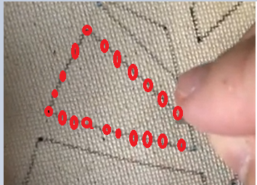
- Once you have poked all the holes, it is time to thread the needle. Wrap one end of the yarn with tape to make it flat and even, cutting the edge to make it easier to thread the needle.

Canvas stitch art instructions

Materials:
- Canvas
- Yarn
- Needle
- Design template
Not provided:
- Pencil
- Tape
- scissors
Video: https://youtu.be/Lc9gzqEBKWM

Instructions:
- Cut out the templet.
- Flip the canvas over, insert the template, and trace the template on the back of the canvas with pencil or pen. Remove the template when finished.
- Use the needle to poke holes in each corner of the outline from the back of the canvas.
- Make more holes along the template lines about 1/16th of an inch apart. You will be sewing the yarn vertically, so poke holes that line up on the top and bottom of the shape.
- Once you have poked all the holes, it is time to thread the needle. Wrap one end of the yarn with tape to make it flat and even, cutting the edge to make it easier to thread the needle.
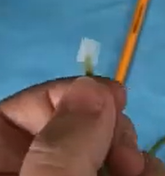
- Tie a knot on the end of thread furthest from the needle, and then start in the of the corners of the bottom shapes.
- Sew the yarn vertically up and down the shape using the holes you poked as guidelines.
- Continue the process until you reach the end of the yarn. Then tie off the end.
- Repeat the process until all the shapes are covered in yarn.

- Tie a knot on the end of thread furthest from the needle, and then start in the of the corners of the bottom shapes.
- Sew the yarn vertically up and down the shape using the holes you poked as guidelines.
- Continue the process until you reach the end of the yarn. Then tie off the end.
- Repeat the process until all the shapes are covered in yarn.

