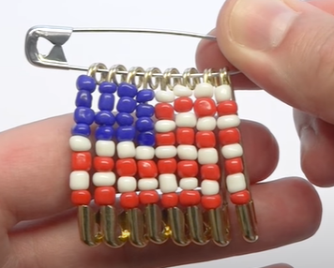
4th of July Pins

Materials:
9 safety pins
16 blue beads
24 white beads
24 red beads
Not Included:
Needle nosed pliers

Video: https://youtu.be/ZPVNjzYm2nE

Instructions:
- Open all the safety pins.
- On the first safety pin, skewer 4 blue beads, then one white bead, one red bead, one white bead, and then one red bead.
- Close the safety pin.
- Repeat steps 2-3, for the second, third and fourth safety pins.
- On the fifth safety pin, start with a white bead, and then a red bead. Continue alternating until you have 4 white and 4 red beads on the pin.
- Close the pin.
- Repeat steps 5-6 another three times, for pins six, seven, and eight.
- Thread the first safety pin onto the largest, ninth safety pin, by going through the small loop on the end opposite the closure.
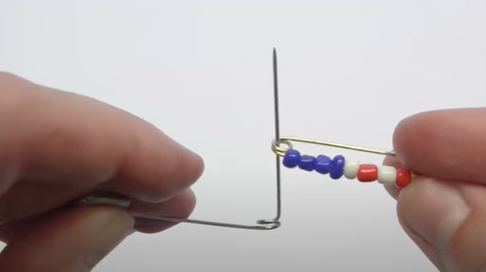
- Continue threading the first safety pin, past the loop on the ninth safety pin (hint it might be challenging to get the safety pin past the loop, so consider separating the pin a bit with some needle nosed pliers)
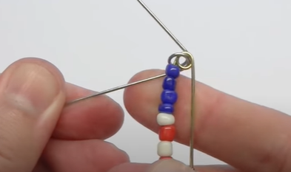
- Repeat step 8-9 for the remaining safety pins in order.
- Bend the 9th safety pin back to its original shape if needed.

