Book Group Selection Ideas
Nov 11, 2021 Edition

Nonfiction Ideas:
Here are some more titles to consider. I picked up most of these ideas from various book group lists. Voting will be in person at our November meeting or by mail if you cannot attend. Have some other ideas? Let me know and I will include them in our next Selection Ideas list.
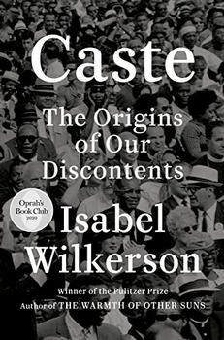
Caste: The Origins of our Discontents by Isabel Wilkerson
Genre: Nonfiction, social science

Selling Points
Popular with book groups
Paperback available.
On Renee’s Reading List

Description:
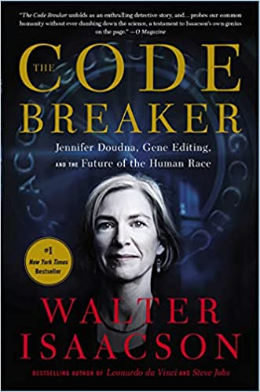
In this brilliant book, Isabel Wilkerson gives us a masterful portrait of an unseen phenomenon in America as she explores, through an immersive, deeply researched narrative and stories about real people, how America today and throughout its history has been shaped by a hidden caste system, a rigid hierarchy of human rankings.
Beyond race, class, or other factors, there is a powerful caste system that influences people's lives and behavior and the nation's fate.

The Code Breaker: Jennifer Doudna, Gene Editing, and the Future of the Human Race by Walter Issacson
Genre: Nonfiction, Science/Biology/Genetics

Selling Points
Award winning biographer’s latest
Women’s History Month Title (March)

Downside:
Longer book at 560 pages, but Walter Isaacson’s books are worth the long haul.

Description:
When Jennifer Doudna was in sixth grade, she came home one day to find that her dad had left a paperback titled The Double Helix on her bed. She put it aside, thinking it was one of those detective tales she loved. When she read it on a rainy Saturday, she discovered she was right, in a way. As she sped through the pages, she became enthralled by the intense drama behind the competition to discover the code of life. Even though her high school counselor told her girls didn’t become scientists, she decided she would.
Driven by a passion to understand how nature works and to turn discoveries into inventions, she would help to make what the book’s author, James Watson, told her was the most important biological advance since his codiscovery of the structure of DNA. She and her collaborators turned a curiosity of nature into an invention that will transform the human race: an easy-to-use tool that can edit DNA. Known as CRISPR, it opened a brave new world of medical miracles and moral questions.

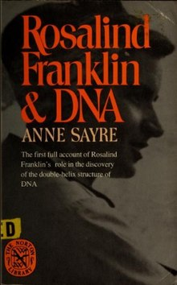
Rosalind Franklin and DNA by Anne Sayre
Genre: Nonfiction, Biography, Science
Selling Points
Great older nonfiction title for Womens History month (March)
Less lengthy than “The Code Breaker” at only 222 pages.
Renee recommends.

Description:
The discovery of the structure of DNA in 1953 is regarded as "the greatest and most important scientific discovery of the 20th Century". Francis Crick, James Watson and Maurice Wilkins received the Nobel Prize in Physiology or Medicine in 1962 for the discovery.^{[5]} This discovery laid the foundation for modern biology, including medical and molecular research. The discoverers earned lasting worldwide fame. But the contribution made by Rosalind Franklin, who died in 1958, was largely forgotten.^{[4]} The main motive for Sayre's book came from James Watson's memoir The Double Helix : A Personal Account of the Discovery of the Structure of DNA. Published in 1968, The Double Helix reflected the account of the discovery in which Franklin was portrayed as "uninteresting", "belligerent", and "sharp, stubborn mind", referring her as "Rosy", the name she did not want to be called. Watson described her as having "all the imagination of English blue-stocking adolescents", and "the product of an unsatisfied mother".^{[7]}

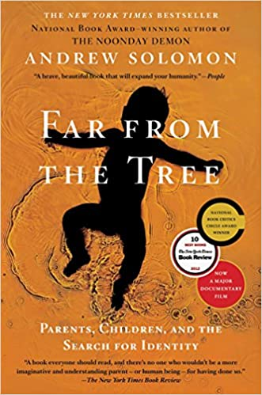
Far From the Tree: Parents, Children, and the search for Identity by Andrew Solomon
Genre: Nonfiction, Neurodiversity, parenting

Selling Points
National Book Award Winner
Book Browse Reading Group Suggestion
Powell’s list of must read books of 21st Century

Downside:
Older title from 2012

Description
Solomon’s startling proposition in Far from the Tree is that being exceptional is at the core of the human condition—that difference is what unites us. He writes about families coping with deafness, dwarfism, Down syndrome, autism, schizophrenia, or multiple severe disabilities; with children who are prodigies, who are conceived in rape, who become criminals, who are transgender. While each of these characteristics is potentially isolating, the experience of difference within families is universal, and Solomon documents triumphs of love over prejudice in every chapter.

All parenting turns on a crucial question: to what extent should parents accept their children for who they are, and to what extent they should help them become their best selves. Drawing on ten years of research and interviews with more than three hundred families, Solomon mines the eloquence of ordinary people facing extreme challenges.

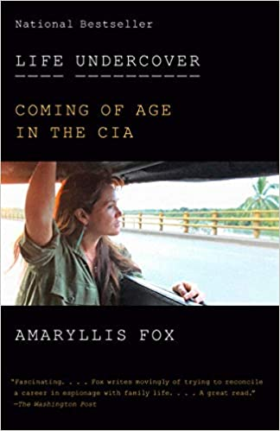
Life Undercover: Coming of Age in the CIA by Amaryllis Fox
Genre: Nonfiction, Biography, CIA

Selling Points
Book Browse Recommended Book Group Title

Description
Amaryllis Fox's riveting memoir tells the story of her ten years in the most elite clandestine ops unit of the CIA, hunting the world's most dangerous terrorists in sixteen countries while marrying and giving birth to a daughter
Amaryllis Fox was in her last year as an undergraduate at Oxford studying theology and international law when her writing mentor Daniel Pearl was captured and beheaded. Galvanized by this brutality, Fox applied to a master's program in conflict and terrorism at Georgetown's School of Foreign Service, where she created an algorithm that predicted, with uncanny certainty, the likelihood of a terrorist cell arising in any village around the world. At twenty-one, she was recruited by the CIA. Her first assignment was reading and analyzing hundreds of classified cables a day from foreign governments and synthesizing them into daily briefs for the president. Her next assignment was at the Iraq desk in the Counterterrorism center. At twenty-two, she was fast-tracked into advanced operations training, sent from Langley to "the Farm," where she lived for six months in a simulated world learning how to use a Glock, how to get out of flexicuffs while locked in the trunk of a car, how to withstand torture, and the best ways to commit suicide in case of captivity. At the end of this training she was deployed as a spy under non-official cover--the most difficult and coveted job in the field as an art dealer specializing in tribal and indigenous art and sent to infiltrate terrorist networks in remote areas of the Middle East and Asia.

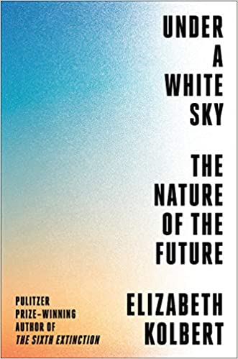
Under a White Sky: The Nature of the Future by Elizabeth Kolbert
Genre: Nonfiction, environmental science

Selling Points:
Pulitzer award winning author of The Sixth Extinction
Book Browse Reading Group Suggestion
On Renee’s to read list.

Description
That man should have dominion “over all the earth, and over every creeping thing that creepeth upon the earth” is a prophecy that has hardened into fact. So pervasive are human impacts on the planet that it’s said we live in a new geological epoch: the Anthropocene.
In Under a White Sky, Elizabeth Kolbert takes a hard look at the new world we are creating. Along the way, she meets biologists who are trying to preserve the world’s rarest fish, which lives in a single tiny pool in the middle of the Mojave; engineers who are turning carbon emissions to stone in Iceland; Australian researchers who are trying to develop a “super coral” that can survive on a hotter globe; and physicists who are contemplating shooting tiny diamonds into the stratosphere to cool the earth.
One way to look at human civilization, says Kolbert, is as a ten-thousand-year exercise in defying nature. In The Sixth Extinction, she explored the ways in which our capacity for destruction has reshaped the natural world. Now she examines how the very sorts of interventions that have imperiled our planet are increasingly seen as the only hope for its salvation. By turns inspiring, terrifying, and darkly comic, Under a White Sky is an utterly original examination of the challenges we face.

